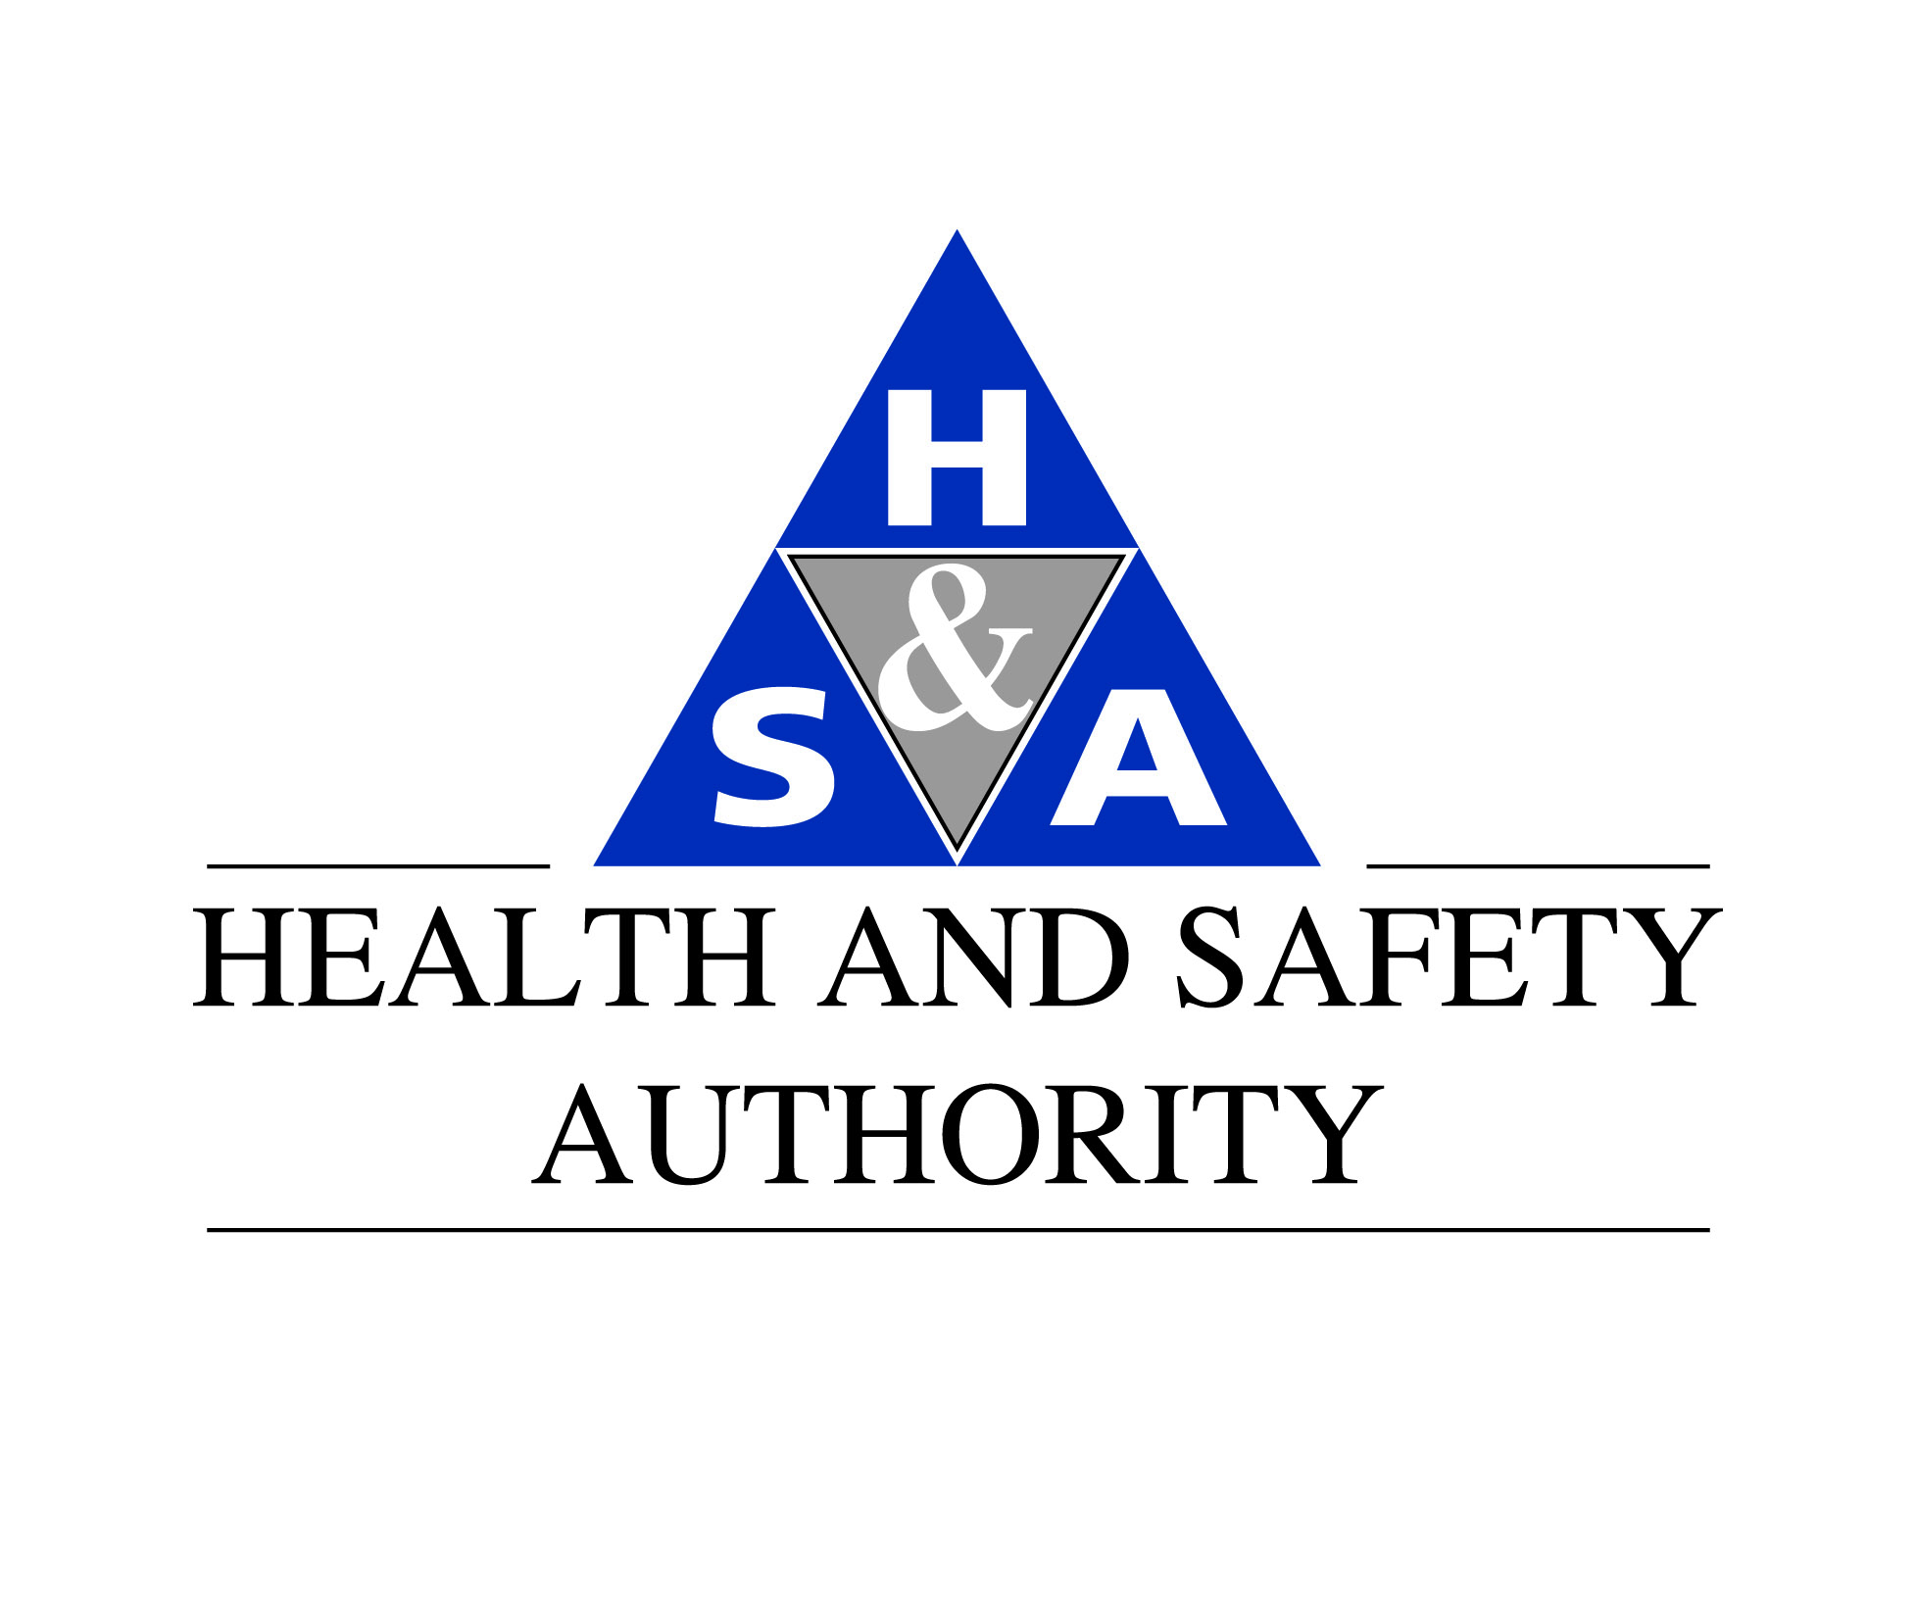
Informal Industry Consultation Paper
Proposed amendments to the European Communities (Carriage of Dangerous Goods by Road and Use of Transportable Pressure Equipment) Regulations 2011 and 2013 concerning Tank Vehicles

Introduction
The Health and Safety Authority propose to review and amend as necessary the above regulations concerning national provisions for the inspection, testing and use of national use only tank vehicles, i.e. Part 8, National Transport Exemptions of S.I. 349 of 2011 as amended by S.I. 238 of 2013.
Consequential amendments and other amendments will be necessary to give effect to ADR 2015 (transposition deadline 1st July 2015) however this paper only deals with proposals in relation to national use tank-vehicles.
Background
Tanks are designed, constructed and maintained in accordance with the European Agreement Concerning the International Carriage of Dangerous Goods by Road (ADR) unless otherwise provided for under national provisions. National provisions are used in several jurisdictions and are provided for under the Inland Transport of Dangerous Goods Directive 2008/68/EU. These national provisions provide some flexibility within the otherwise prescriptive provisions of ADR for the purposes of national transport.
Ireland currently has a number of national provisions concerning tank vehicles that have developed over the last 10 years and more. Some of these national provisions or derogations from ADR have become complicated and are becoming further removed from ADR and from provisions in place in the UK. The significance of having differing standards between the UK and Ireland means potential restriction in trade and services between neighbouring jurisdictions (Ireland, Northern Ireland and Great Britain).

ADR Tanks restricted to national use only.
Currently the most significant derogation from ADR allows an ADR tank-vehicle constructed post 2003 to be treated as if it were an “existing tank”, i.e. as if it were constructed pre 2003. This means the inspection and testing regime, periodic and intermediate testing, may be performed by a competent person (see Notes). This is a significant deviation from ADR as ADR tanks constructed post 2003 must be maintained in accordance with ADR, meaning the inspection and testing regime would require the use of an accredited inspection body approved by the competent authority. In addition, certain tank testing procedures for national use only tanks differs from the testing procedures specified by ADR. In this regard ADR requires a hydraulic test to be performed during periodic testing, whereas current national provisions do not.
It is therefore proposed to amend current regulations to align national provisions more closely to that of ADR and as a consequence, closer to the equivalent provisions in the UK, thus improving safety standards in line with other ADR contracting parties and removing the barrier to operate such vehicles in to the UK (primarily Northern Ireland).
Proposed amendments affecting tank vehicles
Certain vehicles must be certified annually in order to be placed in service. This certification is based on whether the vehicle is used nationally only or in accordance with ADR i.e. for national and international use.
Proposals to align tank vehicle testing and certification with ADR:
- To phase out the national provision allowing ADR tank vehicles, constructed post 1 June 2003, to avail of Regulation 54, National Tanks provisions. The first step in this process will be to remove this provision for new tank vehicles being placed in service from the end of 2015 i.e. affecting tank vehicles issued with an initial annual vehicle certificate of approval issued from 1st January 2016.
- To bring post 2003 ADR tanks that have been treated as national use only tanks back in line with ADR. This proposal to be given effect from the beginning of 2018, meaning for example, a 2010 ADR tank-vehicle that has been treated as a national use only tank will be subject to an inspection and certification regime in line with ADR from 2019 (this would entail two mandatory inspections, at 3 yearly intervals, 2013 and 2016, which may be carried out under current provisions and the third in 2019 would be in accordance with ADR). Testing and certification will only affect a tank vehicle on its next due test date, therefore providing an extended transitional period potentially to 2020 (e.g. a 2014 tank vehicle first intermediate inspection at 2017 may be carried out by a competent person but the first periodic test will be in line with ADR in 2020).
- Exempted from the proposals are fixed tanks constructed post 1 July 2003 carrying UN1202 and or UN1223 exclusively.
- The introduction of a prescriptive tank testing procedure for exempt tanks to be put in place.

Accredited Tank Testing Services
Accreditation requirements for tank testers exist for ADR tank vehicles at present, but this service is only available from service providers based outside Ireland at present. This situation is expected to change as a result of these proposals as demand increases. The time line in this proposal has taken account of the period for which it would be expected to gain appropriate accreditation.
Consideration will be given to exempt certain fixed tanks from the proposals (ref. item 3 above) thereby ensuring the “competent person” regime will be maintained for a defined group of tanks i.e. for tank vehicles involved in the carriage of kerosene, diesel and potentially other defined use vehicles.

Providing Feedback
As part of the informal consultation process industry are asked to provide comment on the proposals, items 1 to 4 above (note at this time no draft tank testing procedure, item 4, has been prepared, but your comments on the principle is sought).
Feedback should be made by email to chemicals@hsa.ie prior to 30th June 2014.
Following submissions by industry it is proposed the HSA will hold a meeting(s) with stakeholders to discuss these proposals and to provide feedback on industry submissions.
This document has been circulated to stakeholders known to the HSA, but if you are aware of potentially affected organisations or representative bodies who are not on the circulation list please advise the Authority or forward this communication to them directly.
This informal consultation paper will be made available on the ADR section of the HSA website, at http://www.hsa.ie/eng/Your_Industry/ADR_-Road_Transport_of_Dangerous_Goods/

Further Information
Draft proposals to national provisions.
Regulation 52(2) of the Principal Regulations (S.I 349 of 2011) as amended by SI 238 of 2013 to be amended (red text) in 2015 as follows:
“Issue of vehicle certificate of approval (national transport only)

52. (1) Notwithstanding Regulation 51 and following the examination of a
vehicle referred to in that Regulation in accordance with Part 9 of the ADR,
where a competent authority or its appointed authorised tester is satisfied that
the vehicle complies with the requirements of Part 9 of the ADR, that authority
or tester shall, in the case of—

(a) a vehicle referred to in paragraph (1) or (2) of Regulation 51, issue a
vehicle certificate of approval (national transport only) for that
vehicle in the format set down in Part 1 of Schedule 3, or

(b) a vehicle referred to in paragraph (3) of Regulation 51, issue a vehicle
certificate of approval (national transport only) for that vehicle in the
format set down in Part 2 of Schedule 3.

(2) A tank-vehicle constructed since 1 July 2003, or in the case of mobile
explosive manufacturing units, since 1 July 2009, in compliance with
ADR, when used exclusively in the State for the carriage of dangerous goods
by road, may be treated, as appropriate, in accordance with Regulation 54, and
the competent authority or their appointed authorised tester may issue a vehicle
certificate of approval (national transport only) for that vehicle in the format
set down in Part 1 of Schedule 3.
(3) Regulation 52(2), as it may apply to new tank-vehicles constructed following the implementation date of these regulations, may only be applied up to and including 31 December 2015.
(4) A tank-vehicle constructed since 1 July 2003 in compliance with ADR, availing of Regulation 52(2), may only continue to do so up to and including 31 December 2017.”
Notes.
“Competent person” as defined by S.I. 349 of 2011, paragraph (2):

(2) (a) For the purposes of the relevant road transport statutory provisions,
a person is deemed to be a competent person where, having regard
to the task he or she is required to perform and taking account of the
size or hazards (or both of them) of the undertaking or establishment
in which he or she undertakes work, the person possesses sufficient
training, experience and knowledge appropriate to the nature of the
work to be undertaken.
(b) Account shall be taken, as appropriate, for the purposes of paragraph
(a) of the framework of qualifications referred to in the Qualifications
(Education and Training) Act 1999.
Accreditation: Accreditation is provided by an accreditation body recognised by the European Co-operation for Accreditation. The competent authority in Ireland responsible for accreditation is INAB at www.INAB.ie
Inspection body: In accordance with ADR an inspection body performing inspections, checks and tests shall be appointed by the competent authority (HSA) and shall be appropriately accredited to EN/ISO 17020.

Please not all queries, requests for clarification etc. should be sent to chemicals@hsa.ie or contact Stephen McGarry at 01 614 7191.

