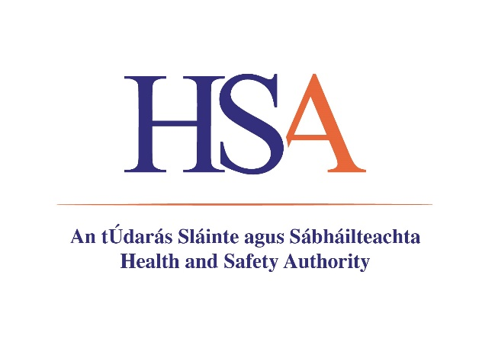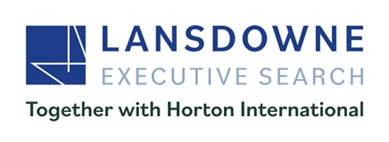

Key Achievements Form

Section 1 – PERSONAL DETAILS

Section 2 – COMPETENCIES

For each competency, briefly set out what you consider to be a good example of how you demonstrated key strengths and skills in these areas. Your example should include a brief description of the nature of the task/problem, your specific involvement, and the outcome (Maximum of 250 words per competency).

Strategic Leadership (Maximum 250 words)
- Develops a clear vision of the future taking account of influencing issues and anticipates the requirements for its delivery.
- Adopts a strategic and systematic approach; anticipates the long-term and cross functional impact of decisions; sees connections, risks and the potential for innovation.
- Adopts a variety of styles and methods to mobilise employees and stakeholders to achieve goals and outcomes.
- Builds and leads a motivated and empowered team
- Leads the organisation within the senior executive team as a strong team player.
- Leads the team in delivering high quality output, maintains high standards and excellent working relationships with customers and stakeholders.

Management and Delivery of Results (Maximum 250 words)
- Builds and supports cross functional and interdepartmental teams.
- Defines roles and responsibilities, sets challenging goals and high expectations for self and others.
- Acts as a role model and mentor, supporting and developing peers, managers and staff through PMDS.
- Coaches and supports staff to optimise their contribution and development.
- Adopts a “best practice” approach to management; uses the full range of management disciplines to deliver quality services and outcomes.
- Secures and effectively manages the resources necessary to enable the Authority to achieve its goals (including budgets, people and IT capability).
- Focuses on results and achievement of agreed outcomes.

Building Relationships and Communication (Maximum 250 words)
- Develops and manages positive working relationships with key customers internal and external to the organisation.
- Uses a variety of networking styles and techniques to effectively interface with a multiplicity of organisations and individuals in order to agree mutually acceptable conclusions and actions.
- Negotiates and influences others to achieve objectives and outcomes.
- Communicates professionally and credibly, managing the expectations of others.
- Facilitates collaboration, partnerships and networks internally and externally to achieve common goals and outcomes.

Drive and Commitment (Maximum 250 words)
- Leads and manages multiple complex priorities effectively.
- Stays positive and professional in the face of difficult situations.
- Assumes accountability for own actions and decisions.
- Shows initiative and sustains high levels of personal drive and energy.
- Is committed to moving the Authority forward in a changing and challenging environment; engages team members in the change programme.
- Identifies opportunities for profitable development activities and performance improvement.

Specialist Knowledge, Expertise and Self Development (Maximum 250 words)
- Has an understanding of the vision and mission of the Health and Safety Authority and its role nationally as a regulator across the full scope of its activities.
- Understands the environment nationally and at European level in which the Authority operates.
- Has a deep understanding of the policy, enforcement and prosecutorial role of the regulator and the need for sound judgement, proportionality and objectivity.
- Has the capacity to quickly master a very wide ranging and complex brief.
- Is self-aware, seeks feedback and opportunities to act on areas for own development.

All parts of the document must be completed and should be submitted, along with a Letter of Application, CV, by 5pm on 12th February 2026

